How to enable L2C and L5 in i-series
Firmware requires: 1.4.5 and later
Operating:
1. Connect to i80 by Wi-Fi and log in to i80 web interface
2. Select Satellites in the left menu and go to tracking enable page
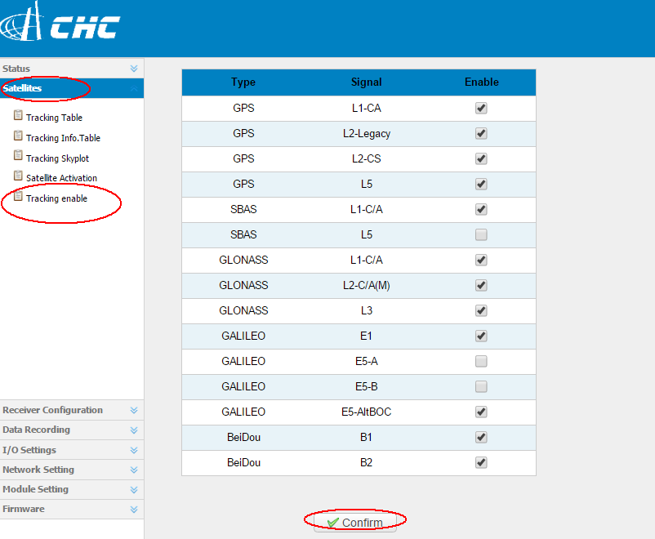
3. Check the GPS L2C, L5, GLONASS L3 and so on… then click Confirm
4. Power off and power on then we will have the tracking option and receive all them

